Project Design Phase-II
Data Flow Diagram & User Stories

Date | 31 January 2025
Team ID
Project Name | Stategic Product Placement Analysis
Maximum Marks | 4 Marks

Data Flow Diagrams:
A Data Flow Diagram (DFD) is a traditional visual representation of the information flows within a system. A neat and clear DFD can depict the right amount of the system requirement graphically. It shows how data enters and leaves the system, what changes the information, and where data is stored.
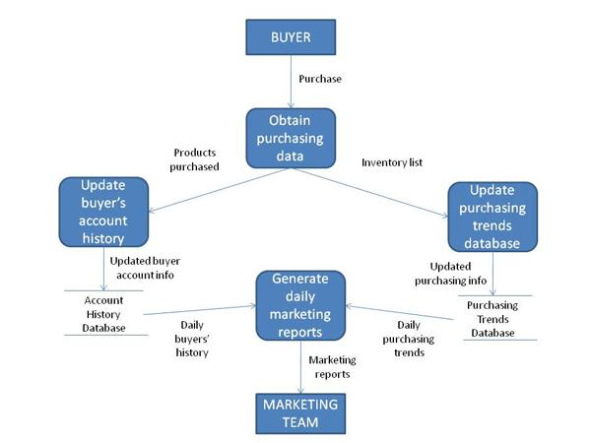

User Stories
User Type | Functional Requirement (Epic) | User Story No. | User Story / Task | Acceptance Criteria | Priority | Release
Business Analyst | Data Import | USN-1 | Import sales, product placement, and customer demographic data into Tableau. | Data is imported successfully. | High | Sprint-1
Business Analyst | Data Cleaning | USN-2 | Clean and prepare the dataset for analysis. | Clean dataset is ready for visualization. | High | Sprint-1
Business Analyst | Dashboard Development | USN-3 | Create interactive Tableau dashboards. | Dashboards display accurate visualizations. | High | Sprint-1
Marketing Manager | Product Position Analysis | USN-4 | Analyse the impact of product positioning on sales. | Dashboard identifies high-performing product placements. | High | Sprint-2
Marketing Manager | Consumer Behaviour Analysis | USN-5 | Analyse customer purchasing behaviour using demographic data. | Consumer insights are displayed through charts. | High | Sprint-2
Sales Manager | Sales Performance | USN-6 | Compare sales performance across products and regions. | Sales trends and comparisons are available. | Medium | Sprint-2
Management | Business Insights | USN-7 | View KPIs and recommendations to improve product positioning strategies. | Dashboard provides actionable insights for decision-making. | High | Sprint-3

